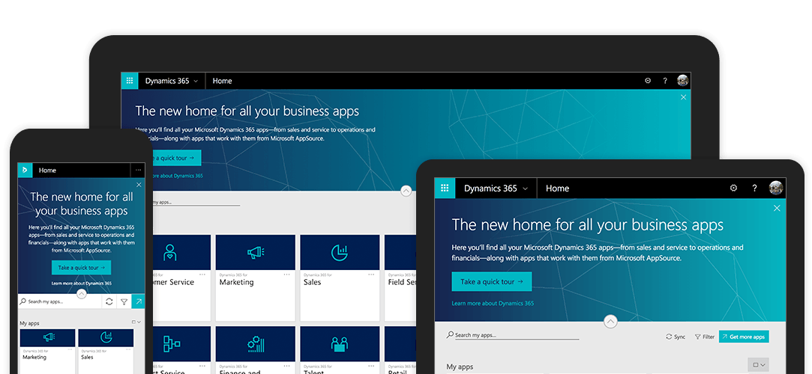

**The Microsoft Dynamics 365 Experience**

**Enabling Digital Transformation with Intelligent Business Applications for Government**

Hands-On Labs

Manual

Employee Leave Request

This page intentionally left blank.

Contents

Lab 1 – Create a Custom Solution 5

Lab 2 – Add An Existing Business Entity to a Custom Solution 7

Lab 3 – Customize the User Entity 9

Lab 4 – Create a Custom Leave Request Entity 11

Lab 5 – Add Custom Entity Fields 14

Lab 6 – Create a Custom Request Approval “Lookup” Entity 16

Lab 7 – Configuring Views and Charts 19

Lab 8 – Configuring Dashboards 24

Lab 9 – Configure Business Rules in Dynamics 365 26

Lab 10 – Configure a Workflow in Dynamics 365 30

Lab 11 – Configure a Dynamics 365 Portal Form 33

Lab 12 – Configure a Leave Request PowerApp 40

This page intentionally left blank.

Lab 1 – Create a Custom Solution

In this lab we will configure a custom solution within Microsoft Dynamics 365. This solution will be leveraged in future Labs in this manual.

**Solutions** are how customizers and developers author, package, and maintain units of software that extend Microsoft Dynamics 365 (online & on-premises). Customizers and developers distribute solutions so that organizations can use Microsoft Dynamics 365 to install and uninstall the business functionality defined by the solution.

Goals of this Lab

At the end of this Lab, users:

* will understand the difference between the default and custom solutions in Dynamics 365.
* Will be able to create (configure) a new custom solution in Dynamics 365

Your Lab Environment

To begin, sign in to your Microsoft Dynamics 365 Trial Tenant with a user account that has either the System Customizer or System Administrator Security Role.

Create a Custom Solution

1. On the navigation bar, select the **Settings** Area.
2. Select the **Solutions** Entity.
3. A list of all Solutions will be displayed.
4. Click **New** in the command bar.
5. The New Solution form will be displayed.
6. Use the table on the next page to complete the fields on the form.
7. Click **Save**.

**Table: Custom Solution - Field Names and Values**

|  |  |
| --- | --- |
| Field Name | Value |
| Display Name | Leave Request |
| Publisher | (Select) Default Publisher |
| Version | 1.0.0.0 |
| Description | [Enter description for this Dynamics 365 Solution] |

Lab 2 – Add An Existing Business Entity to a Custom Solution

In this lab we will add an existing (Default Solution) entity within Microsoft Dynamics 365 to the custom solution created in Lab 1. This solution will be leveraged in future Labs in this manual.

**Entities** are used to model and manage business data in Microsoft Dynamics 365. For example, entities such as account, campaign, and incident (case) can be used to track and support sales, marketing, and service activities. An entity has a set of attributes and each attribute represents a data item of a particular type. For example, the account entity has Name, Address, and OwnerId attributes. Conceptually, an entity is like a database table, and the entity attributes correspond to the table columns. Creating an entity record (or, simply a record) in Microsoft Dynamics 365 is like adding a row in a database table. The entities are divided into three categories: system, business, and custom. As a developer working with business data, you will use business and custom entities. System entities are used by Microsoft Dynamics 365 to handle all internal processes, such as workflows and asynchronous jobs. You cannot delete or customize system entities.

Business entities are part of the Microsoft Dynamics 365 default installation and they appear in the customization user interface. An account, contact, and letter are examples of business entities.

Goals of this Lab

At the end of this Lab, users:

* will understand the difference among the various types of entities within Dynamics 365.
* Will be able to add an existing Business entity to a custom solution in Dynamics 365

Your Lab Environment

To begin, sign in to your Microsoft Dynamics 365 Trial Tenant with a user account that has either the System Customizer or System Administrator Security Role.

Add an Existing Business Entity to your Custom Solution

1. On the navigation bar, select the **Settings** Area.
2. Select the **Solutions** Entity. A list of all Solutions will be displayed.
3. Open the custom Solution you created in Lab 1.
4. In the command bar, Click **Add Existing** > **Entity**
5. Select the **User** Entity.

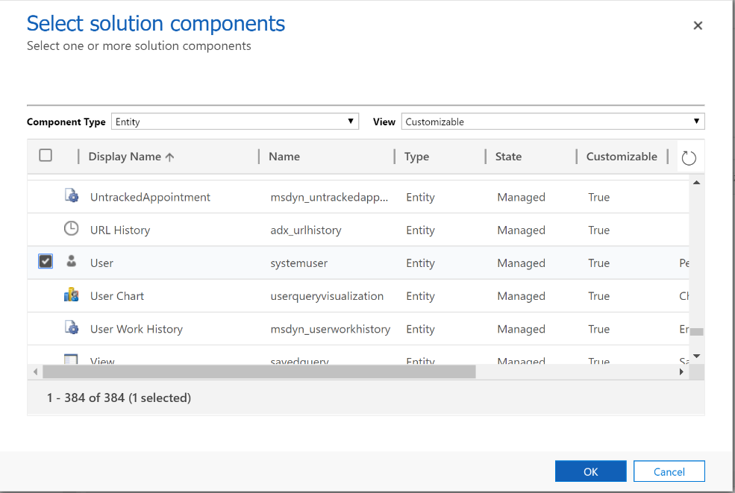

1. Click **OK**.
2. Select **Add All Assets** in the upper right corner of the **User Assets** screen.
3. Click **Finish**.
4. If you receive a warning about required components, select **Do not include…**
5. Repeat steps 4 through 9, adding the existing **Contact** Entity to your custom solution.

Lab 3 – Customize the User Entity

In this lab we will modify the existing User (Business) entity that we added to our solution in Lab 2. We’ll modify, remove and add new fields to the contact form.

Entities and their **Fields** are the foundation of Dynamics 365. As a visual example, you can think of Entities like a table in Excel, and Fields are each column. Dynamics 365 removes the rigidity of the tabular appearance by providing users a very appealing interface, but at its core, Dynamics 365 is a very sophisticated set of tables with large numbers of columns.

Goals of this Lab

At the end of this Lab, users:

* Will understand Dynamics 365 Fields (data types and UI configuration)
* Will be able to modify existing fields, create new fields and remove unwanted fields from entity forms.

Your Lab Environment

To begin, sign in to your Microsoft Dynamics 365 Trial Tenant with a user account that has either the System Customizer or System Administrator Security Role.

Customize fields on the User form

1. On the navigation bar, select the **Settings** Area.
2. Select the **Solutions** Entity. A list of all Solutions will be displayed.
3. Open the custom Solution you created in Lab 1.
4. Navigate to **Entities** > **User** > **Forms**
5. Open the main **User** form.
6. Hide the “Title” Field on the Form.
7. Change the Label of “Main Phone” to “Primary Phone”.
8. Remove the “Fax Number” Field from the Form.
9. Create a New Field “Employee Number”.
   1. Click **New Field.** The New Field form will be displayed.
   2. Use the table on the next page to complete the fields on the form.
   3. Click **Save and Close**
   4. Drag new field onto the form
10. Save and Publish All Configurations

**Table: Custom Field - Field Names and Values**

|  |  |
| --- | --- |
| Field Name | Value |
| Display Name | Employee Number |
| Field Requirement | Optional |
| Description | [Enter description for this Dynamics 365 Field] |
| Data Type | Single Line of Text |
| Maximum Length | 10 |

Lab 4 – Create a Custom Leave Request Entity

In this lab we will create a custom entity within Microsoft Dynamics 365 for the custom solution created in Lab 1. This solution will be leveraged in future Labs in this manual.

Business entities are part of the Microsoft Dynamics 365 default installation, and they appear in the customization user interface. An account, contact, and letter are examples of business entities. After installation, you can add **custom entities** to Microsoft Dynamics 365 to address specific business needs of the organization.

Goals of this Lab

At the end of this Lab, users:

* Extend Dynamics 365 by creating a custom entity within an existing Solution in Dynamics 365.

Your Lab Environment

To begin, sign in to your Microsoft Dynamics 365 Trial Tenant with a user account that has either the System Customizer or System Administrator Security Role.

Add a Custom Entity to your Solution

1. On the navigation bar, select the **Settings** Area.
2. Select the **Solutions** Entity. A list of all Solutions will be displayed.
3. Open the custom Solution you created in Lab 1
4. Navigate to **Entities**. A list of all Entities within the Solution will be displayed.
5. Select **New** from the Entities Menu. The New Entity form will be displayed.
6. Use the tables on the next pages to complete the fields on the form.
7. Only after completing the tasks in both of the following tables, click **Save** to create the entity.

**Table: Custom Entity - Field Names and Values**

|  |  |
| --- | --- |
| Field Name | Value |
| Display Name | Leave Request |
| Plural Name | Leave Requests |
| Ownership | (Select) User or Team |
| Description | [Enter description for this Dynamics 365 Entity] |
| Areas | Service |
| Business Process Flows | [Leave Unchecked] |
| Communication & Collaboration | Ensure only the following are checked:   * Notes * Activities * Connections |
| Data Services | Ensure only the following are checked:   * Duplicate Detection * Auditing |
| Outlook & Mobile | Ensure only the following are checked:   * Enable for Phone Express * Enable for Mobile * Reading Pane in Dynamics 365 for Outlook * Offline Capability for Dynamics 365 for Outlook |

**Table: Entity Primary Field - Field Names and Values**

|  |  |
| --- | --- |
| Field Name | Value |
| Display Name | Request Number |
| Field Requirement | Optional |
| Description | [Enter description for this Dynamics 365 Field] |
| Data Type | Single Line of Text |
| Maximum Length | 15 |

Lab 5 – Add Custom Entity Fields

In this lab we will add custom fields to the Entity created in the previous lab. This Entity will be leveraged in future Labs in this manual.

Create new **Fields** to capture data when existing system entities don’t have fields that meet your requirements. After you create new fields, be sure to include them on the forms and views for the entity so that they are available from the relevant app user interface.

Goals of this Lab

At the end of this Lab, users:

* Will create several custom fields and add them to a UI form.
* Wil update properties of the Main UI form.

Your Lab Environment

To begin, sign in to your Microsoft Dynamics 365 Trial Tenant with a user account that has either the System Customizer or System Administrator Security Role.

Add Custom Fields to your Entity Form

1. On the navigation bar, select the **Settings** Area.
2. Select the **Solutions** Entity. A list of all Solutions will be displayed.
3. Open the custom Solution you created in Lab 1
4. Navigate to **Entities > Leave Request > Forms**. A list of all Forms for the Entity will be displayed.
5. Open the Main Form for the Leave Request entity.
6. Click **New Field.** The New Field form will be displayed.
   1. Use the table on the next page to complete the fields on the form.
   2. Click **Save and Close**
   3. Drag new field onto the form
   4. [Repeat for each Custom Field]
7. Save and Publish All Configurations

**Table: Custom Fields - Field Names and Values**

|  |  |  |
| --- | --- | --- |
| Field Name | Data Type | Properties |
| Leave Type | Option Set | * Business Required * Option Values:   Vacation  Sick Leave  Extended Leave |
| Begin Date | Date/Time | * Business Required * Date Only |
| Return Date | Date/Time | * Business Recommended * Date Only |
| Request Details | Multiple Lines of Text | * Optional * Length=2000 * Display 4 Rows |
| Requester | Lookup | * Business Required * To **User** Entity |

Update the Display Name of Your Entity Form

1. On the navigation bar, select the **Settings** Area.
2. Select the **Solutions** Entity. A list of all Solutions will be displayed.
3. Open the custom Solution you created in Lab 1
4. Navigate to **Entities > Leave Request > Forms**. A list of all Forms for the Entity will be displayed.
5. Open the **Main Form** for the Leave Request entity.
6. From the ribbon on the Form Editor screen, Click **Form Properties.** This will display the properties for the **Main Form**. Select the **Display** tab.
7. Replace the Form Name **Information** with **Leave Request Main Form**. Click **OK**.
8. Save and Close the Form Editor. Publish All Configurations.

Lab 6 – Create a Custom Leave Request Status “Lookup” Entity

In this lab we will create a custom entity within Microsoft Dynamics 365 to the custom solution created in Lab 1. This solution will be leveraged in future Labs in this manual.

Business entities are part of the Microsoft Dynamics 365 default installation and they appear in the customization user interface. An account, contact, and letter are examples of business entities. After installation, you can add **custom entities** to Microsoft Dynamics 365 to address specific business needs of the organization.

Goals of this Lab

At the end of this Lab, users:

* Will understand the differences between Option Set and Lookup Fields and when to use each.
* Visualize a related List of Values within the previously created Leave Request form.

Your Lab Environment

To begin, sign in to your Microsoft Dynamics 365 Trial Tenant with a user account that has either the System Customizer or System Administrator Security Role.

Add a Custom “Lookup” Entity to your Solution

1. On the navigation bar, select the **Settings** Area.
2. Select the **Solutions** Entity. A list of all Solutions will be displayed.
3. Open the custom Solution you created in Lab 1
4. Navigate to **Entities**. A list of all Entities within the Solution will be displayed.
5. Select **New** from the Entities Menu. The New Entity form will be displayed.
6. Use the tables on the next pages to complete the fields on the form.
7. Only after completing the tasks in both of the following tables, click **Save** to create the entity.

**Table: Custom Lookup Entity - Field Names and Values**

|  |  |
| --- | --- |
| Field Name | Value |
| Display Name | Leave Request Status |
| Plural Name | Leave Request Status |
| Ownership | (Select) Organization |
| Description | [Enter description for this Dynamics 365 Entity] |
| Areas | Service |
| Business Process Flows | [Leave Unchecked] |
| Communication & Collaboration | Ensure only the following are checked:   * Connections |
| Data Services | Ensure only the following are checked:   * Duplicate Detection * Auditing |
| Outlook & Mobile | Ensure only the following are checked:   * Enable for Phone Express * Enable for Mobile * Reading Pane in Dynamics 365 for Outlook * Offline Capability for Dynamics 365 for Outlook |

**Table: Entity Primary Field - Field Names and Values**

|  |  |
| --- | --- |
| Field Name | Value |
| Display Name | Request Status |
| Field Requirement | Required |
| Description | [Enter description for this Dynamics 365 Field] |
| Data Type | Single Line of Text |
| Maximum Length | 50 |

Add a Custom “Lookup” Field to your Leave Request Entity

1. On the navigation bar, select the **Settings** Area.
2. Select the **Solutions** Entity. A list of all Solutions will be displayed.
3. Open the custom Solution you created in Lab 1
4. Navigate to **Entities > Leave Request > Forms**. A list of all Forms for the Entity will be displayed.
5. Open the **Main Form** for the Leave Request entity.
6. Click **New Field.** The New Field form will be displayed.
7. Use the table below to complete the fields on the form.
8. Click **Save and Close**
9. Double click the Header section of the form.
10. Drag the new field onto the **Header** section of the form.
11. Save and Publish All Configurations

**Table: Custom Fields - Field Names and Values**

|  |  |  |
| --- | --- | --- |
| Field Name | Data Type | Properties |
| Request Status | Lookup | * Optional * To **Leave Request Status** Entity |

Add Data Values to your Leave Request Status “Lookup” entity.

1. On the navigation bar, select the **Service** Area. Scroll the Service menu bar to the far right.
2. Under the **Extensions** Group, select the **Leave Request Status** Entity. A list of all Request Statuses will be displayed. (Though, initially this list will be empty).
3. Click the New button at the top left of the Command Bar. In the Request Status field enter “Pending”. Click Save. Repeat this process adding the following values to the Request Approvals: “Approved”, “Not Approved” and “Conditionally Approved”.

Lab 7 – Configuring Views and Charts

In this lab we will configure lists of records (or views) and charts leveraging the Entities created in the previous labs. These configurations will be leveraged in future Labs in this manual.

In Microsoft Dynamics 365, use views to define how a list of records for a specific entity is displayed in the application. A **view** defines:

* The columns to display
* How wide each column should be
* How the list of records should be sorted by default
* What default filters should be applied to restrict which records will appear in the list

A drop-down list of views is frequently displayed in the application so that people have options for different views of entity data.

The records that are visible in individual views are displayed in a list, sometimes called a grid, which frequently provides options so that people can change the default sorting, column widths, and filters to more easily see the data that’s important to them. Views also define the data source for charts that are used in the application.

Present large quantities of data in your organization in a more insightful and graphical way by creating useful **charts** in Dynamics 365.

Goals of this Lab

At the end of this Lab, users:

* Will be able to configure default and custom views for Dynamics 365 Entities.
* Will be able to configure custom charts for Dynamics 365 Entities

Your Lab Environment

To begin, sign in to your Microsoft Dynamics 365 Trial Tenant with a user account that has either the System Customizer or System Administrator Security Role.

Configure a default Entity View

1. On the navigation bar, select the **Settings** Area.
2. Select the **Solutions** Entity. A list of all Solutions will be displayed.
3. Open the custom Solution you created in Lab 1
4. Navigate to **Entities > Leave Request > Views**. A list of all Views for the Entity will be displayed.
5. Double-click to open the **Active** Leave Requests View.
6. Modify the view, adding and removing fields, ordering fields, and changing the sort order.

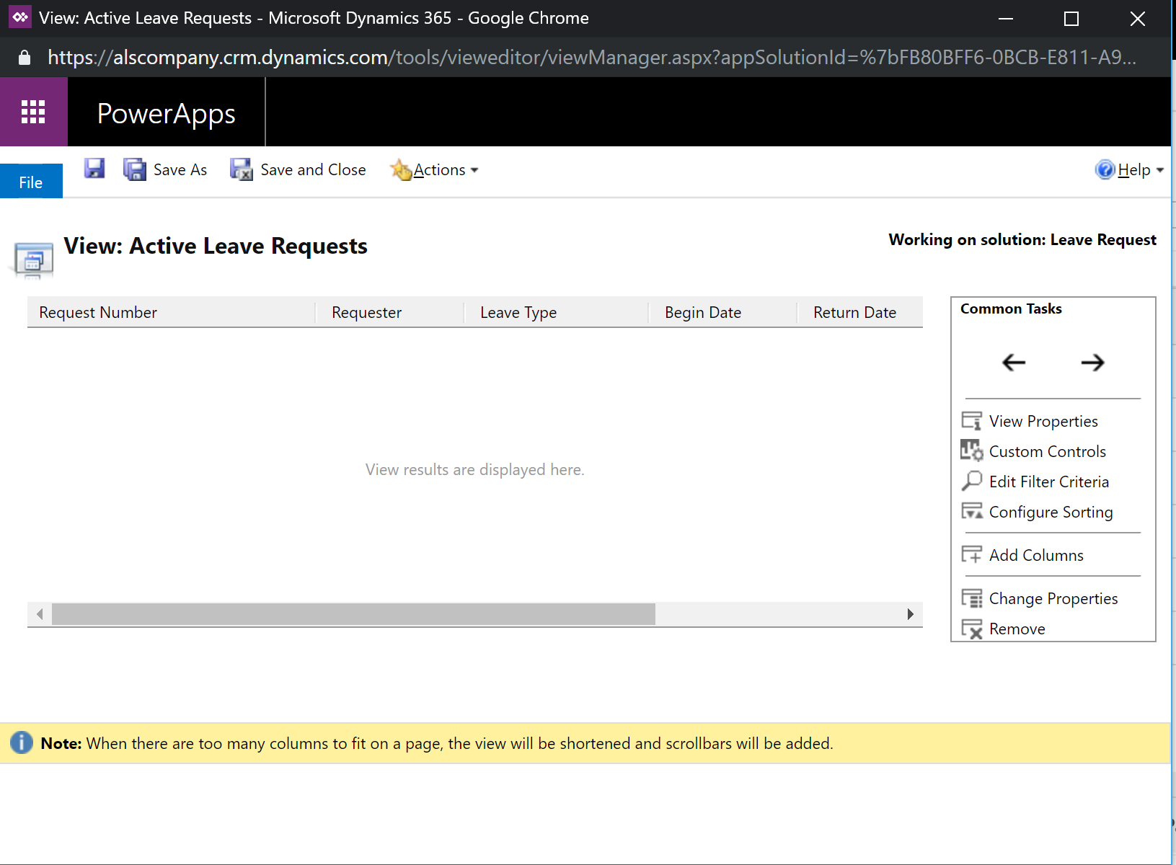

1. Click **Save and Close**.
2. Publish All Configurations

Configure a custom Entity View

1. On the navigation bar, select the **Settings** Area.
2. Select the **Solutions** Entity. A list of all Solutions will be displayed.
3. Open the custom Solution you created in Lab 1
4. Navigate to **Entities > Leave Request > Views**. A list of all Views for the Entity will be displayed.
5. Double-click to open the **Active** Leave Requests View.
6. Click **Save As**
7. On the View Properties screen, update the name of the new view to My Leave Requests
8. Add a clause to the view Filter Criteria: **Requester Equals Current User**.
9. Click **OK**.
10. Click **Save and Close**.
11. Publish All Configurations

Configure a custom Chart (Leave Requests by Request Status)

1. On the navigation bar, select the **Settings** Area.
2. Select the **Solutions** Entity. A list of all Solutions will be displayed.
3. Open the custom Solution you created in Lab 1
4. Navigate to **Entities > Leave Request > Charts**.
5. Click New to create a new Chart.
6. In the ribbon, select the **Pie** chart type.
7. On the Chart Editor screen, enter **Leave Requests by Request Status** in the name field.
8. Under **Legend Entries (Series)**, select **Leave Request** from the dropdown. Leave the data aggregation selection as **Count:All**.
9. Under **Horizontal (Category)**, select **Request Status** from the dropdown.
10. A preview of the chart will render.

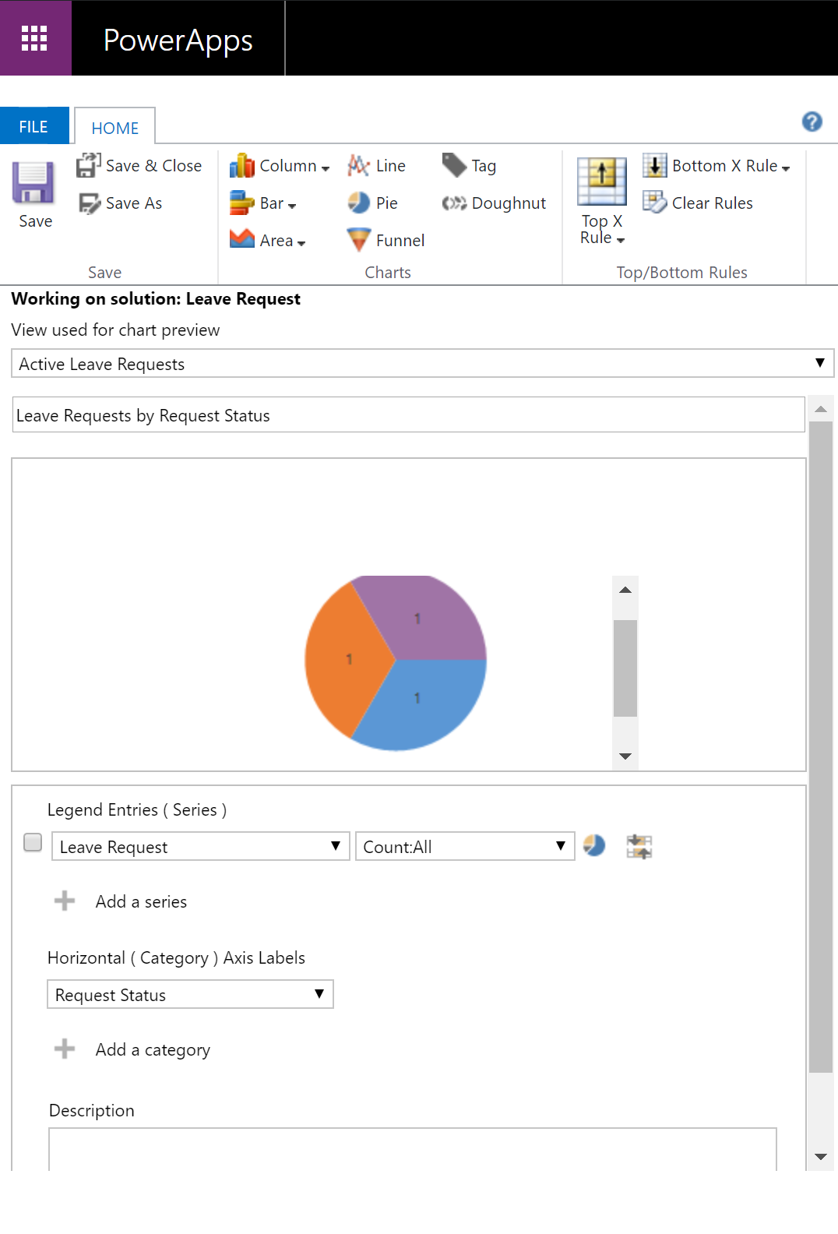

1. Click **Save and Close**.
2. Publish All Configurations.

Configure a custom Chart (Leave Requests by Leave Type)

1. On the navigation bar, select the **Settings** Area.
2. Select the **Solutions** Entity. A list of all Solutions will be displayed.
3. Open the custom Solution you created in Lab 1
4. Navigate to **Entities > Leave Request > Charts**.
5. Click New to create a new Chart.
6. In the ribbon, select the **Column** chart type.
7. On the Chart Editor screen, enter **Leave Requests by Leave Type** in the name field.
8. Under **Legend Entries (Series)**, select **Leave Request** from the dropdown. Leave the data aggregation selection as **Count:All**.
9. Under **Horizontal (Category)**, select **Leave Type** from the dropdown.
10. A preview of the chart will render.

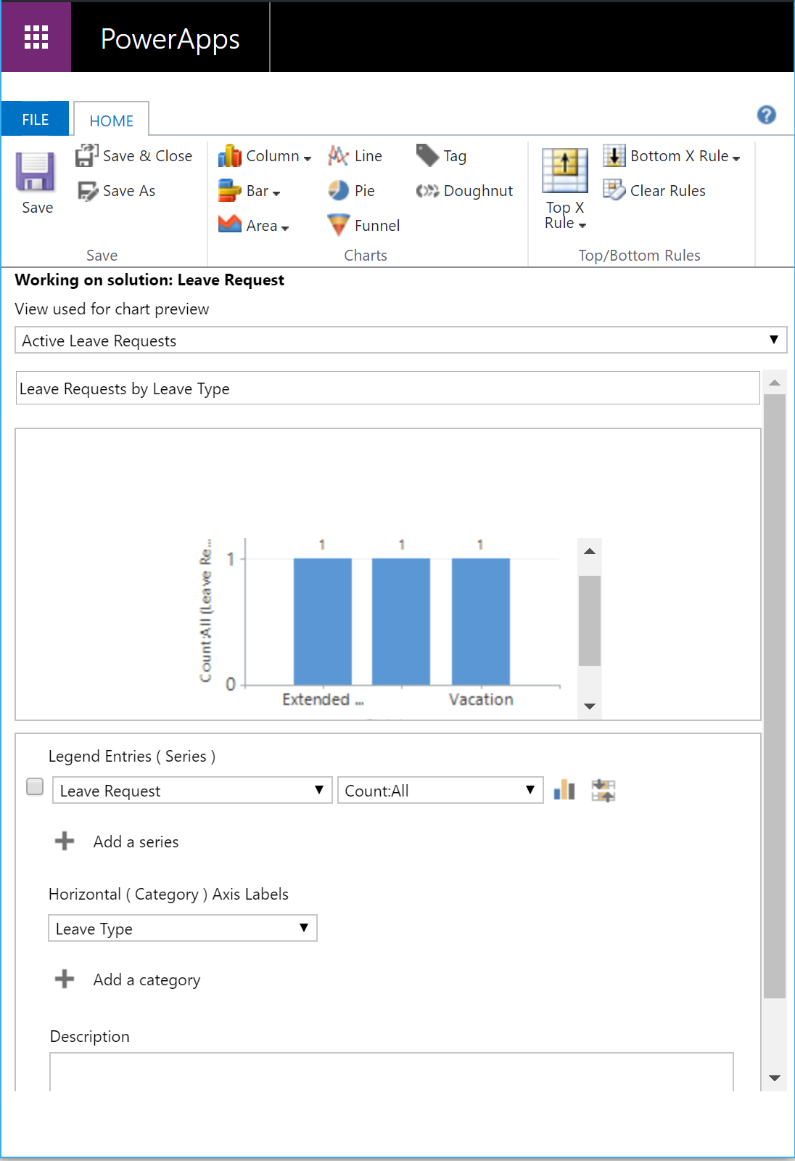

1. Click **Save and Close**.
2. Publish All Configurations.

Lab 8 – Configuring Dashboards

In this lab we will configure a Dashboard intended to be used by an individual responsible for reviewing or approving Leave Requests.

Microsoft Dynamics 365 **dashboards** are collections of view lists, charts, web resources, iFrames, and organization insights that can pull in things like website information that you can modify to show key performance indicators and other important data. An admin or customizer creates or customizes system dashboards that, when published, are visible to everyone in the organization. A user can choose to set their user dashboard as their default dashboard and override the system dashboard. This topic focuses on system dashboards.

Goals of this Lab

At the end of this Lab, users:

* Will understand the importance of dashboards in Dynamics 365.
* Configure a dashboard specific to Leave Request processing.

Your Lab Environment

To begin, sign in to your Microsoft Dynamics 365 Trial Tenant with a user account that has either the System Customizer or System Administrator Security Role.

Add Configured Components (Views and Charts) to a Dashboard

1. On the navigation bar, select the **Settings** Area.
2. Select the **Solutions** Entity. A list of all Solutions will be displayed.
3. Open the custom Solution you created in Lab 1
4. Navigate to **Dashboards**.
5. Click **New > Dashboard**. This will display the available dashboard templates.
6. Select the **2-Column Regular Dashboard** layout and click **Create**.
7. On the Dashboard Editor screen, enter **Leave Request Dashboard** in the name field.
8. Add the previously configured **Leave Requests by Request Approval** chart and **Active** and **My Leave Requests** views to the dashboard by clicking the related **Insert** icon (list, chart, etc.) within each frame of the dashboard template.
9. Click **Save**. Click **Close**.
10. Publish All Configurations.

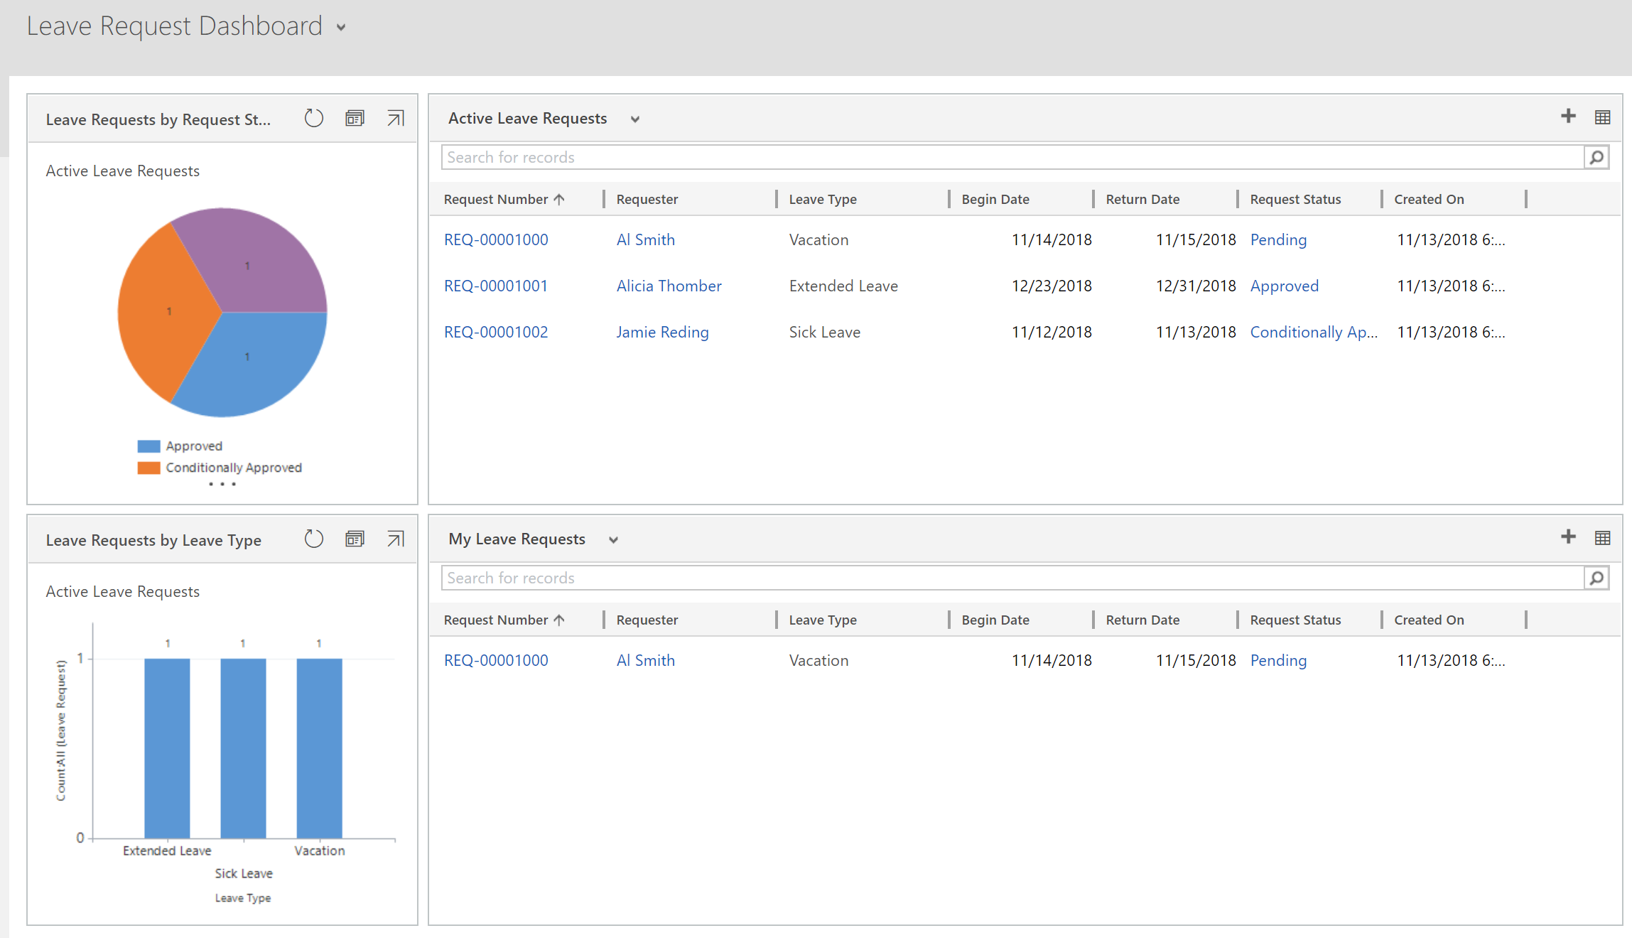

Lab 9 – Configure Business Rules in Dynamics 365

In this lab we will add business logic to the Leave Request Entity created in the previous labs.

You can create **business rules** and recommendations to apply form logic without writing JavaScript code or creating plug-ins. Business rules provide a simple interface to implement and maintain fast-changing and commonly used rules. They can be applied to Main and Quick Create forms, and they work in PowerApps apps, Dynamics 365 web apps, Dynamics 365 for tablets, and Dynamics 365 for Outlook (online or offline mode).

Goals of this Lab

At the end of this Lab, users:

* Will understand how to apply business logic within Dynamics 365 Entity Forms.
* Will be able configure business rules leveraging the drag-and-drop canvas within the Business Rules editor.

Your Lab Environment

To begin, sign in to your Microsoft Dynamics 365 Trial Tenant with a user account that has either the System Customizer or System Administrator Security Role.

Configuring Business Rules for a Dynamics 365 Form

1. On the navigation bar, select the **Settings** Area.
2. Select the **Solutions** Entity. A list of all Solutions will be displayed.
3. Open the custom Solution you created in Lab 1
4. Navigate to **Entities > Leave Request > Business Rules**.
5. Click New to configure a new Business Rule. This will open the Business Rule editor.
6. Expand the header and enter **Leave Request Date Validation** as the **Business rule name**.
7. Click on the **Condition** Component on the canvas. This will display the Component Properties in the right pane. Configure the Condition as follows:

**Table: Business Rule - Field Names and Values**

|  |  |
| --- | --- |
| Field Name | Value |
| Display Name | Check Dates |
| Entity | Leave Request |

1. Under Rules, configure the Rule as follows:

**Table: Business Rule – Rule 1 Properties**

|  |  |
| --- | --- |
| Field Name | Value |
| Source | Entity |
| Field | Return Date |
| Operator | Contains data |

1. Click +New to add a new Rule. Configure the Rule (Rule 2) as follows:

**Table: Business Rule – Rule 2 Properties**

|  |  |
| --- | --- |
| Field Name | Value |
| Source | Entity |
| Field | Begin Date |
| Operator | Is greater than |
| Type | Field |
| Value | Return Date |

1. Select **AND** from the **Rule Logic** dropdown.
2. Click Apply. The Text View will show the Business logic in process.

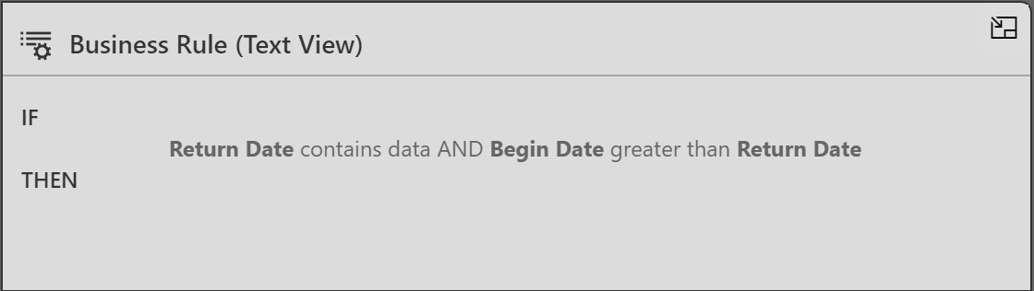

1. Click on the **Components** Tab and drag a **Show Error Message** component onto the canvas. Place the component linked to the True (check mark) branch of the Check Dates condition.

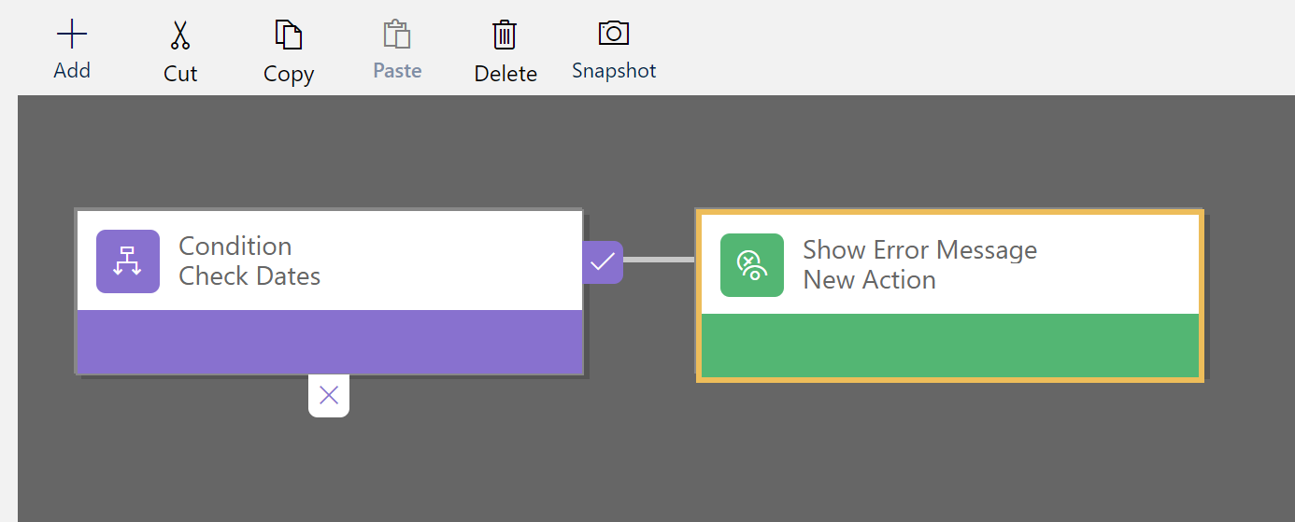

1. Click on the new **Show Error Message** Component on the canvas. This will display the Component Properties in the right pane. Configure the component as follows:

**Table: Business Rule - Field Names and Values**

|  |  |
| --- | --- |
| Field Name | Value |
| Display Name | Display Date Error Message |
| Entity | Leave Request |
| Field | Begin Date |
| Message | Begin Date cannot be greater than End Date |

1. Click Apply.
2. Save, Validate and Activate the new **Leave Request Date Validation** Business Rule.
3. Test the new **Leave Request Date Validation** Business Rule.

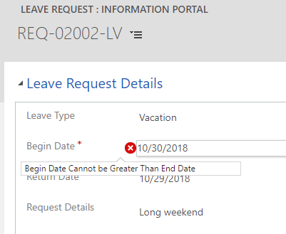

Lab 10 – Configure a Workflow in Dynamics 365

In this lab we will add the custom Leave Request entity form to the Dynamics Portal.

**Workflows** automate business processes without a user interface. They are generally used to initiate automation that doesn’t require any user interaction. Each workflow process is associated with a single entity.

When configuring consider the following:

* When to start them?
* Should they run as a real-time workflow or a background workflow?
* What actions should they perform?
* Under what conditions should actions be performed?

Goals of this Lab

At the end of this Lab, users:

* Will understand what Workflows are and how they automate business processes within Dynamics.
* Will be able configure a workflow leveraging the Workflow editor.

Your Lab Environment

To begin, sign in to your Microsoft Dynamics 365 Trial Tenant with a user account that has either the System Customizer or System Administrator Security Role.

Configuring A Workflow

1. On the navigation bar, select the **Settings** Area.
2. Select the **Solutions** Entity. A list of all Solutions will be displayed.
3. Open the custom Solution you created in Lab 1
4. Navigate to **Components > Processes**.
5. Click New to create a new Workflow. Configure the Workflow as follows:

**Table: Workflow – Definition Names and Values**

|  |  |
| --- | --- |
| Field Name | Value |
| Process Name | c |
| Category | Workflow |
| Entity | Leave Request |
| Run this workflow… | UNCHECK |
| Type | New blank process |

1. Click **OK**. This will open the Dynamics 365 Workflow editor.
2. Under **Options for Automatic Processes**, select **Organization** as the **Scope**. Select to **Start when (After) Record is created**.
3. Drop down the **Add Step** list and select **Update Record**. Click **Set Properties** for the **Leave Request** Entity.
4. In the **Request Approval** field select the desired default approval value (**Pending**). Click **Save and Close**.
5. Drop down the **Add Step** list and select **Stop Workflow**.

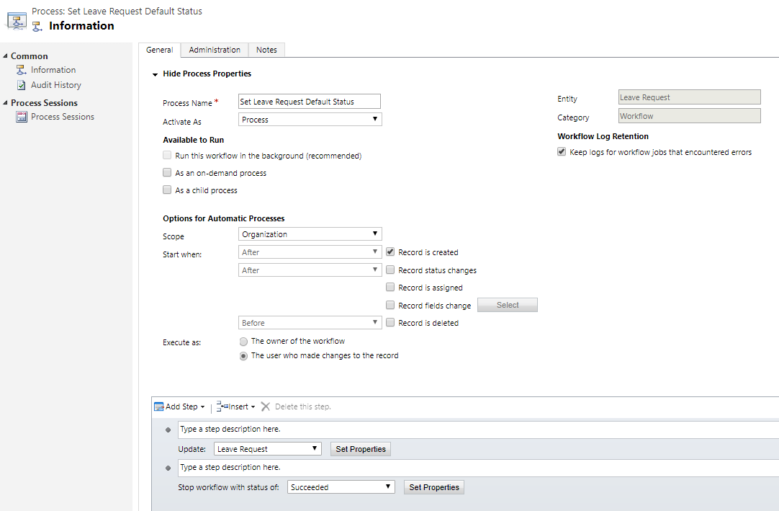

1. Save and Activate the new **Set Leave Request Default Status** Workflow.
2. Test the new **Set Leave Request Default Status** Workflow by creating a new Leave Request.

Lab 11 – Configure a Dynamics 365 Portal Form

In this lab we will add the custom Leave Request entity form to the Dynamics Portal.

**Portal capabilities for Dynamics 365** bring an integrated bundle of web portal solutions that add sophisticated content management, knowledge and case management, opportunity management, membership, profile, and self-service capabilities to Dynamics 365. You can use Portals to set up interactive, web-based sales, service, and support platforms to engage with communities, manage portal content, and empower your channel partners.

Goals of this Lab

At the end of this Lab, users:

* Will understand how to register for access to the Dynamics Portal as an administrator.
* Will be able to expose Dynamics forms via the Portal.
* Will see how the Dynamics Portal serves as another user interface, allowing a user to interact directly with the Dynamics Customer Engagement database.

Your Lab Environment

To begin, sign in to your Microsoft Dynamics 365 Trial Tenant with a user account that has either the System Customizer or System Administrator Security Role.

Creating Portal Content using a Dynamics 365 Form

1. On the navigation bar, select the **Portals** Area.
2. Navigate to **Administration** > **Portal Management**
3. Select the **Create Portal Content** menu item.
4. Populate the form as follows, taking care to select **Yes** for the last two parameters – **Allow record creation** and **Allow anonymous access**.

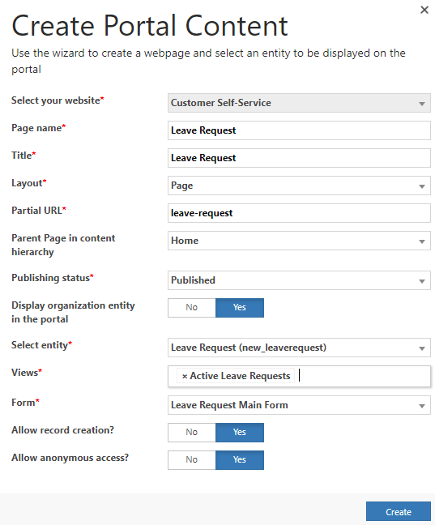

1. Click the **Create** button.

Configure Portal Entity Forms

1. On the navigation bar, select the **Portals** Area.
2. Navigate to the **Entity Forms** menu item. Please note that two Entity Forms have been created by the content wizard – **Leave Request Create** and **Leave** **Request Details**.
3. Open the **Leave Request Create** record and de-select the **Enable Entity Permissions** check box (shown below). Please ensure that the **Form Name** field value resolves to “Leave Request Main Form” prior to saving the record in the next step.
4. Save and close the record.
5. Repeat steps 3 and 4 for the **Leave Request Details** record.

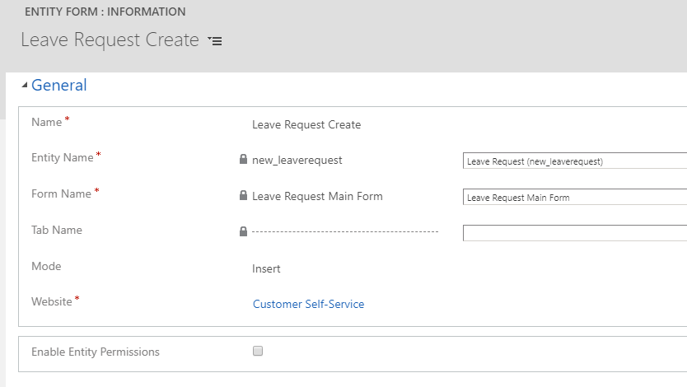

Register for access to the Dynamics Portal

1. Open the Dynamics Portal in another browser tab. The portal URL should look like ***<your trial company>.microsoftcrmportals.com***
2. From the Portal navigation, select the **Sign In** menu item.
3. Select the **Register** tab, and populate the form as follows.

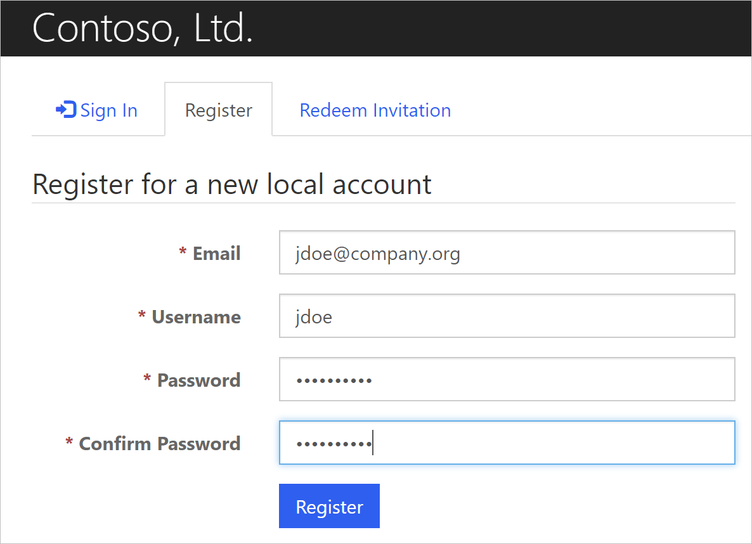

1. On the **Profile** form, supply a **First Name**, **Last Name**, and **E-mail** address.
2. Scroll down and select the **Update** button to complete the sign-up process.

Grant Administrator Web Role to Newly Created Portal User

1. Return to the Dynamics 365 application tab in the same browser window.
2. Navigate to **Portals** > **Contacts**
3. Use the View Selector to display the **All Contacts** view.
4. Select the newly registered contact.
5. Use the Form selector to display the **Portal Contact** form
6. Under the Web Roles section of the form, add the “Administrators” **Web Role** to the Contact record.

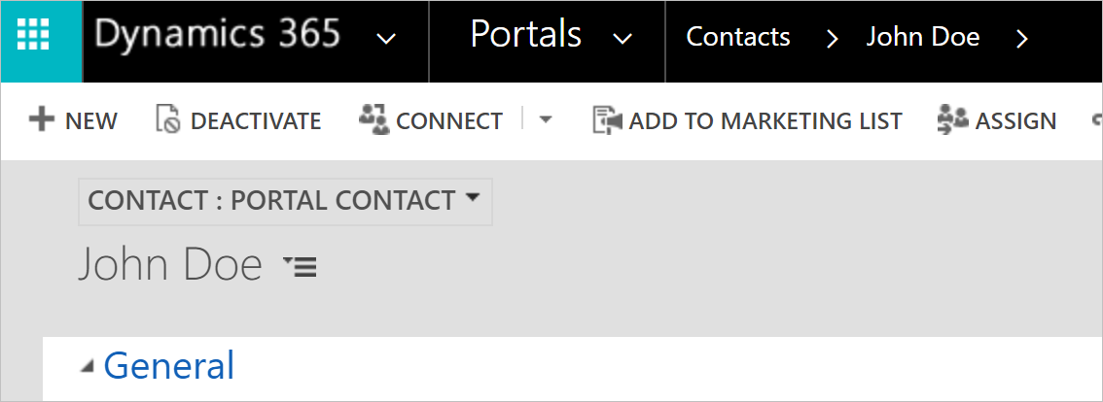

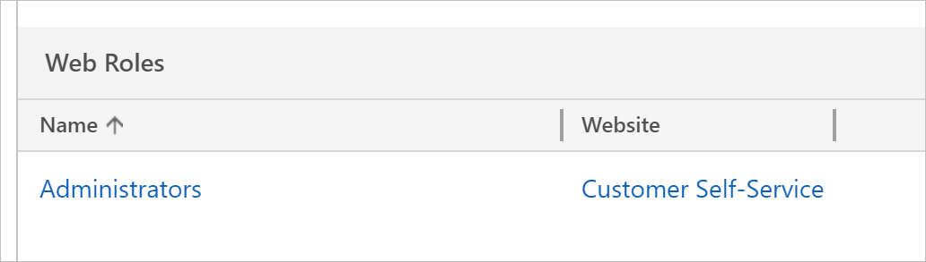

Add Leave Request Entity Form to the Dynamics Portal

1. Return to the Dynamics Portal tab in the same browser window.
2. **Sign Out**, and then **Sign In** again to refresh your Portal User’s Administrator access.
3. You will now have access to the Content Editor Tool in the upper-right portion of your screen.

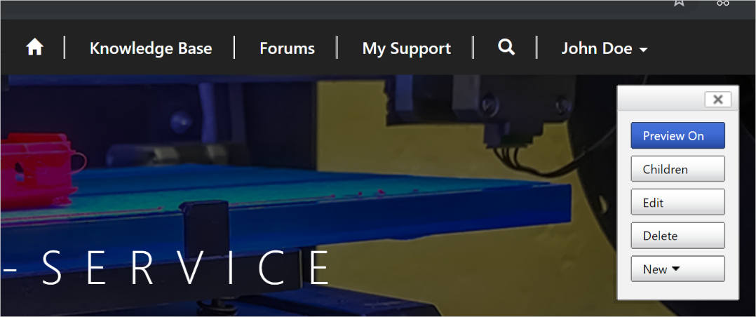

1. Hover over the menu navigation, i.e. home icon, Knowledge Base, etc., and select the **Edit | Primary Navigation** button.
2. Click the green plus (+) sign icon to add a new link to the Portal menu bar.

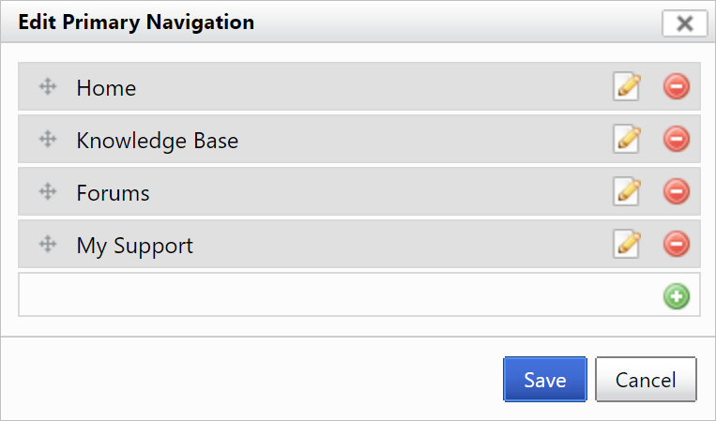

1. Select the **Leave Request** (landing) webpage. Note: Be certain **not** to select either the Create nor Details Pages.

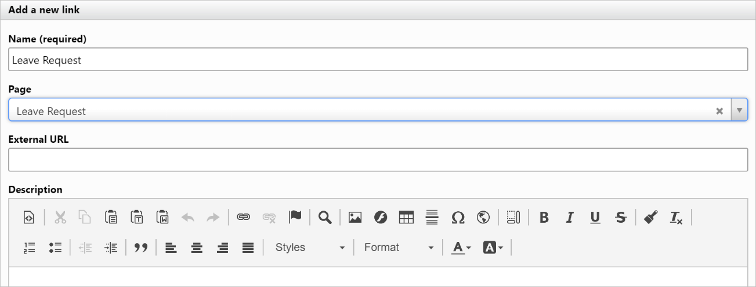

1. Save the wizard.

Access the Leave Request Entity Form via the Portal

1. Select the new **Leave Request** menu item in the home navigation, which will take you to a list of existing Leave Requests.

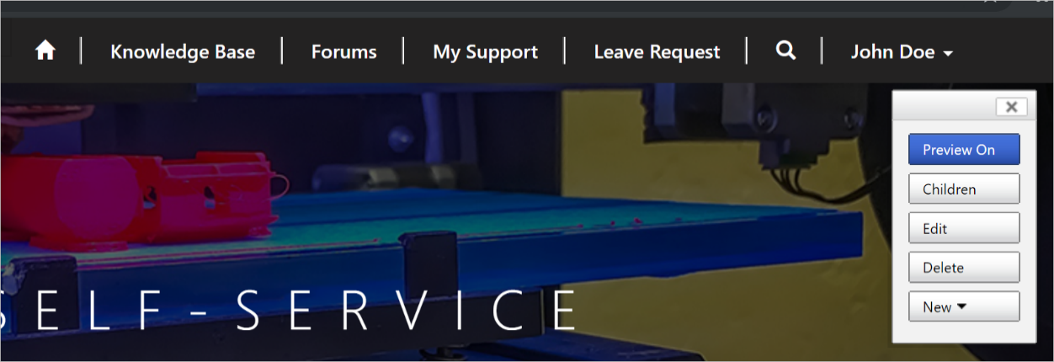

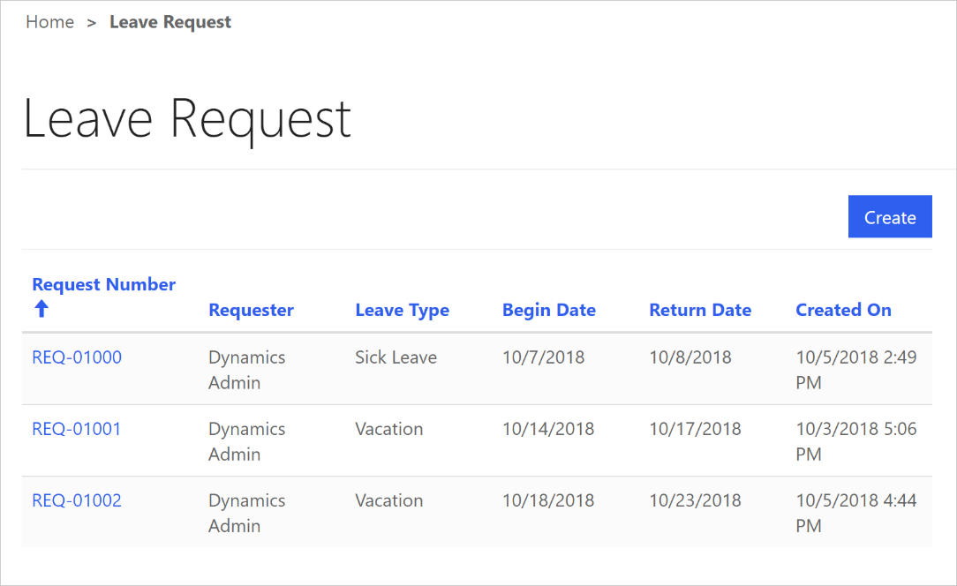

1. Clicking the **Create** button will display the **Leave Request Create** page (and form ready for user input).
2. Clicking an existing **Request Number** link will display the read-only **Leave Request Details** page.

Lab 12 – Configure a Leave Request PowerApp

In this lab we will create a custom mobile application leveraging PowerApps.

PowerApps help you to build mobile applications fast with a point-and-click approach to app design. Choose from a large selection of templates or start from a blank canvas. Easily connect your app to data and use Excel-like expressions to easily add logic. Publish your app to the web, iOS, Android, and Windows 10. When other app platforms stop, PowerApps keeps going. Pro-developer extensibility is natively built into the platform, allowing developers to seamlessly extend app capabilities using Azure Functions or use custom connectors to connect to custom or legacy systems.

Goals of this Lab

At the end of this Lab, users:

* Will understand how PowerApps extend Dynamics 365 solutions to a mobile platform.
* Will create a functional PowerApp for Leave Requests.

Your Lab Environment

To begin, sign in to your Microsoft Dynamics 365 Trial Tenant with a user account that has either the System Customizer or System Administrator Security Role.

In a new tab, navigate to <https://powerapps.microsoft.com> (Click **Sign In** if not automatically authenticated)

Select a Template to Configure

Templates are quick ways to create apps that use connected data sources. Starting with a template provides you:

* Pre-built layouts and color schemes for different app screens that you can directly use or clone.
* Understanding how controls are being configured for common actions, such as how to submit data from a form by clicking on a button, how to transition from one app screen to the other, how to show a list of items from my data, etc.
* Understanding how data flows in and out of your app and how to wire up your data source to your app.
* Understanding how camera or GPS are being integrated into your app.

1. On the PowerApps Home screen, hover over the **Start from data** template and click **Make this app**.
2. Under **Start with your data**, select Dynamics 365 Phone Layout.
3. On the Connections page, Click **Create**. The entities (tables) available within Dynamics 365 will be displayed.
4. Choose **Leave Requests** from the list. Click **Connect**. PowerApps will build out the application framework including a Browse Screen, Detail Screen and Edit Screen for configuration.

Update the default Object Names

The default names for the various screens, galleries, cards, etc. can be updated to more descriptive and meaningful names. This promotes ease of configuration while creating your PowerApp as well as ease of maintenance when this PowerApp is revisited for updates or enhancements.

**Change the Name of the Browse, Detail and Edit Screens**

1. Within the left pane, click and select the **BrowseScreen1** Object
2. Click the ellipsis (…) next to the **BrowseScreen1** Object and select **Rename**
3. Replace BrowseScreen1 with **LeaveRequestBrowseScreen**.
4. Repeat steps 1-3for the remaining screens, changing **DetailScreen1** to **LeaveRequestDetailScreen** and **EditScreen1** to **LeaveRequestEditScreen**.

Saving Your PowerApp

**Saving Your PowerApp**

1. On the Main Menu, Click **File**.
2. Under App Settings, enter **Leave Requests** as **the App name**, select an **Icon** and **Background color** of your choice.
3. Enter a **Description** for this PowerApp.
4. Under Save As, click **Save**.
5. Click the back arrow at the top of the screen.

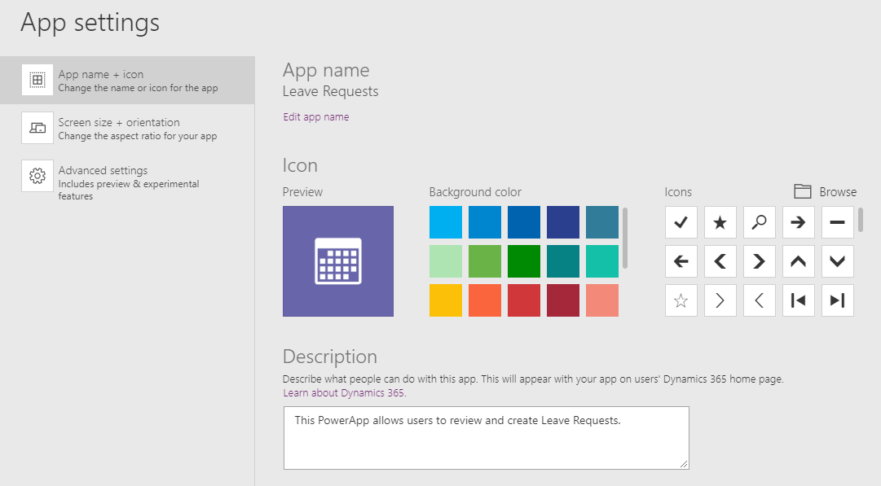

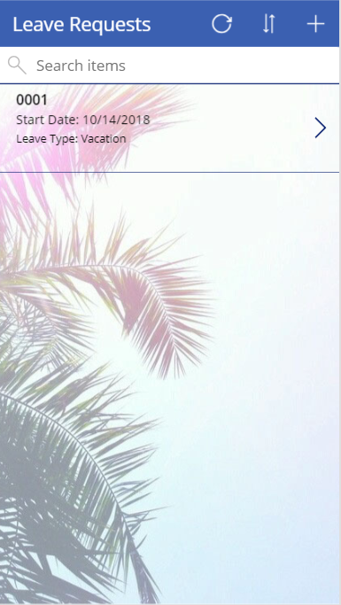Configure the Browse Screen

**Add a Background Image**

1. With **LeaveRequestBrowseScreen** selected in the left pane, click **Properties** on the right side of the screen.
2. Change the Background image property by clicking **Select an image…** and **Add an image file**. Select the **App Background.jpg** file and click **Open**.
3. Adjust the Image Position to **Fill**.
4. Save your changes to your PowerApp.

**Modify/Select Fields for Browse**

1. On the Main Menu, Click **View**.
2. Click **Data sources** on the submenu. This will display the Data pane.
3. Under BrowseGallery1, click Subtitle1. Change the data field in the Data pane from **Created On** to **Begin Date**.
4. In the formula (*fx*) field, enter the following: *"Start Date: " & ThisItem.new_begindate*
5. Under BrowseGallery1, click Body1. Change the data field in the Data pane from **Owner** to **Leave Type Label**.
6. In the formula (*fx*) field, enter: *"Leave Type: " & ThisItem._new_leavetype_label*
7. Save your changes to your PowerApp.

Testing your PowerApp

To preview your PowerApp while configuring, click the play button in the upper right corner of the screen.



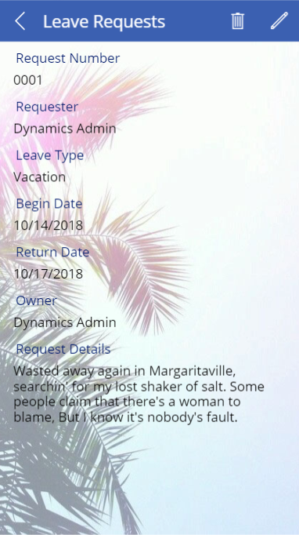Configure the Detail Screen

**Add a Background Image**

1. With **LeaveRequestDetailScreen** selected in the left pane, click Properties on the right side of the screen.
2. Change the Background image property to **App Background**.
3. Adjust the Image Position to **Fill**.
4. Save your changes to your PowerApp.

**Modify/Select Fields for Details**

Detail fields are organized into Cards. Card controls are the building blocks of the Edit form and Display form controls in PowerApps. The form represents the entire record, and each card represents a single field of that record.

1. On the Main Menu, Click **View**.
2. Click **Data sources** on the submenu. This will display the Data pane.
3. Select **DetailForm1** to display the field pane. On the field pane, select the following fields and drag up or down to reorder the fields:
   * Request Number
   * Requester
   * Leave Type Label
   * Begin Date
   * Return Date
   * Request Details
   * Owner
   * CreatedOn
4. In the list of data fields, click the ellipsis (…) next to the **Leave Type Label** field and click **Advanced Options**. Under the Advanced tap, Click the **Unlock to change properties** link. Change the **DisplayName** field from **Leave Type Label** to **Leave Type**.
5. Save your changes to your PowerApp.

LookUp Function in PowerApps

We use the LookUp Function in PowerApps to display related entity values on a screen.

**Add the Related Contact Entity DataSource**

1. On the Main Menu, Click **View**.
2. Click **Data sources** on the submenu. This will display the Data pane.
3. Click **Add data source** and select your **Dynamics 365** source.
4. Select the **Contacts** Entity and click **Connect**.

**Invoke the LookUp Function to Display the Requester’s Name**

1. On the **LeaveRequestDetailScreen > DetailForm1**, Select the **Requester DataCard**. Select the **DataCardValue** field on the card.
2. Under the Advanced Tab, set to Unlock field to modify
3. In the formula (*fx*) field, enter: *LookUp(Contacts,contactid=ThisItem._new_requester_value,fullname)*

**Add the Related User Entity DataSource**

1. On the Main Menu, Click **View**.
2. Click **Data sources** on the submenu. This will display the Data pane.
3. Click **Add data source** and select your **Dynamics 365** source.
4. Select the **Users** Entity and click **Connect**.

**Invoke the LookUp Function to Display the Owner’s Name**

1. On the **LeaveRequestDetailScreen > DetailForm1**, Select the **Owner DataCard**. Select the **DataCardValue** field on the card.
2. If the field is locked for editing, under the **Advanced** Tab, set to Unlock field to modify
3. In the formula (*fx*) field, enter: *LookUp(Users,systemuserid=ThisItem._ownerid_value,fullname)*

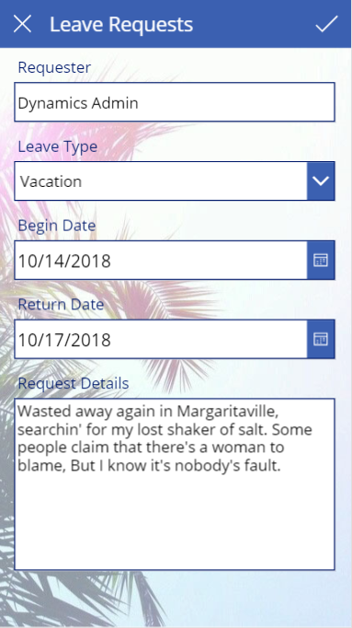Configure the Edit Screen

**Add a Background Image**

1. With **LeaveRequestEditScreen** selected in the left pane, click Properties on the right side of the screen.
2. Change the Background image property to **App Background**.
3. Adjust the Image Position to **Fill**.
4. Save your changes to your PowerApp.

**Modify/Select Fields for Edit**

Edit fields are organized into Cards. Card controls are the building blocks of the Edit form and Display form controls in PowerApps. The form represents the entire record, and each card represents a single field of that record.

1. On the Main Menu, Click **View**.
2. Click **Data sources** on the submenu. This will display the Data pane.
3. Select EditForm1 to display the field pane. On the field pane, select the following fields and drag up or down to reorder the fields:
   * Request Number
   * Requester
   * Leave Type Label
   * Begin Date
   * Return Date
   * Request Details
   * Owner
   * CreatedOn
4. In the list of data fields, click the ellipsis (…) next to the **Leave Type Label** field and click **Advanced Options**. Under the Advanced tap, Click the **Unlock to change properties** link. Change the **DisplayName** field from **Leave Type Label** to **Leave Type**.
5. On the form, click on the Request Details FIELD. This will display the options for the text field. If necessary, click the **Unlock to change properties** link. Change the **Mode** field from **TextMode.SingleLine** to **TextMode.MultiLine**.
6. Save your changes to your PowerApp.

LookUp Function in PowerApps

We use the LookUp Function in PowerApps to display related entity values on a screen.

**Invoke the LookUp Function to Display the Requester’s Name**

1. On the **LeaveRequestEditScreen > EditForm1**, Select the **Requester DataCard**. Select the **DataCardValue** field on the card.
2. Under the Advanced Tab, set to Unlock field to modify.
3. In the formula (*fx*) field, enter: *LookUp(Contacts,contactid=ThisItem._new_requester_value,fullname)*
4. Save your changes to your PowerApp.

**Invoke the LookUp Function to Display the Owner’s Name**

1. On the **LeaveRequestDetailScreen > DetailForm1**, Select the **Owner DataCard**. Select the **DataCardValue** field on the card.
2. If the field is locked for editing, under the **Advanced** Tab, set to Unlock field to modify
3. In the formula (*fx*) field, enter: *LookUp(Users,systemuserid=ThisItem._ownerid_value,fullname)*

Testing your PowerApp

To preview your PowerApp while configuring, click the play button in the upper right corner of the screen.



Publishing your PowerApp

1. Save your changes to your PowerApp.
2. After changes are saved, a **Publish** button will be displayed. Click the Publish button.
3. On the Publish screen, click **Publish this version**.
4. Your PowerApp is now published and accessible to all users in the organization.

NOTICE

This document contains sensitive confidential and proprietary information and intellectual property of Microsoft Corporation. Review, use, and reproduction is only permitted by external entities solely as necessary for the purposes for which it was given, and solely subject to the terms of any non-disclosure agreement with Microsoft. No further distribution to third parties is permitted.

The information contained in this document represents the current view of Microsoft Corporation on the issues discussed as of the date of publication and is subject to change at any time without notice. This document and its contents are provided AS IS without warranty of any kind and should not be interpreted as an offer or commitment on the part of Microsoft. Microsoft cannot guarantee the accuracy of any information presented. MICROSOFT MAKES NO WARRANTIES, EXPRESS OR IMPLIED, IN THIS DOCUMENT.

The descriptions of other companies’ products in this document, if any, are provided only as a convenience to our customers. Any such references should not be considered an endorsement or support by Microsoft. Microsoft cannot guarantee their accuracy, and the products may change over time.

All trademarks are the property of their respective companies.

Microsoft and Dynamics 365 are either registered trademarks or trademarks of Microsoft Corporation in the United States and/or other countries.

©2018 Microsoft Corporation. All rights reserved

Questions regarding this document can be addressed to:

**Al Smith**

**Chief Business Applications Architect**

al.smith@microsoft.com